BPSK
helperModClassGetModulator
function y = bpskModulator(x,sps)
%bpskModulator BPSK modulator with pulse shaping
% Y = bpskModulator(X,SPS) BPSK modulates the input X, and returns the
% root-raised cosine pulse shaped signal Y. X must be a column vector
% of values in the set [0 1]. The root-raised cosine filter has a
% roll-off factor of 0.35 and spans four symbols. The output signal
% Y has unit power.

persistent filterCoeffs
if isempty(filterCoeffs)
filterCoeffs = rcosdesign(0.35, 4, sps);
end
% Modulate
syms = pskmod(x,2);
% Pulse shape
y = filter(filterCoeffs, 1, upsample(syms,sps));
end
% Random bits
d = randi([0 1], 1024, 1);
% PAM4 modulation
syms = pskmod(d,2);

prediction1 = 7×1 categorical
BPSK
BPSK
BPSK
BPSK
BPSK
BPSK
BPSK
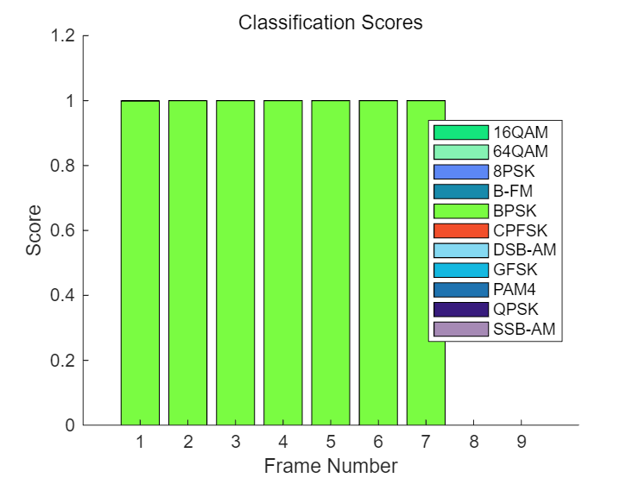

QPSK
helperModClassGetModulator
function y = qpskModulator(x,sps)
%qpskModulator QPSK modulator with pulse shaping
% Y = qpskModulator(X,SPS) QPSK modulates the input X, and returns the
% root-raised cosine pulse shaped signal Y. X must be a column vector
% of values in the set [0 3]. The root-raised cosine filter has a
% roll-off factor of 0.35 and spans four symbols. The output signal
% Y has unit power.

persistent filterCoeffs
if isempty(filterCoeffs)
filterCoeffs = rcosdesign(0.35, 4, sps);
end
% Modulate
syms = pskmod(x,4,pi/4);
% Pulse shape
y = filter(filterCoeffs, 1, upsample(syms,sps));
end
d = randi([0 3], 1024, 1);
% PAM4 modulation
syms = pskmod(d,4,pi/4);
prediction1 = 7×1 categorical
QPSK
QPSK
QPSK
QPSK
QPSK
QPSK
QPSK
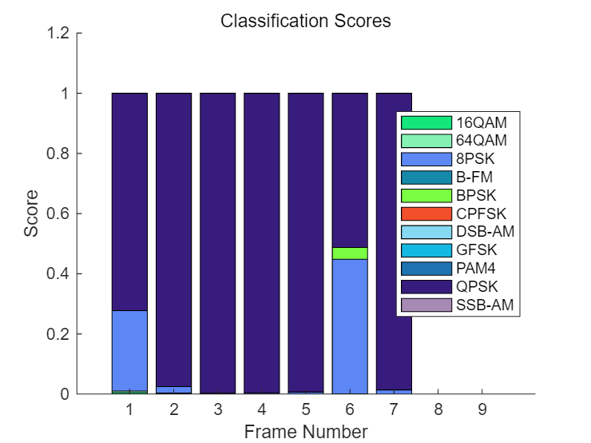

8PSK
helperModClassGetModulator
function y = psk8Modulator(x,sps)
%psk8Modulator 8-PSK modulator with pulse shaping
% Y = psk8Modulator(X,SPS) 8-PSK modulates the input X, and returns the
% root-raised cosine pulse shaped signal Y. X must be a column vector
% of values in the set [0 7]. The root-raised cosine filter has a
% roll-off factor of 0.35 and spans four symbols. The output signal
% Y has unit power.

persistent filterCoeffs
if isempty(filterCoeffs)
filterCoeffs = rcosdesign(0.35, 4, sps);
end
% Modulate
syms = pskmod(x,8);
% Pulse shape
y = filter(filterCoeffs, 1, upsample(syms,sps));
end
% Random bits
d = randi([0 7], 1024, 1);
% PAM4 modulation
syms = pskmod(d,8);
prediction1 = 7×1 categorical
8PSK
8PSK
8PSK
8PSK
8PSK
8PSK
8PSK
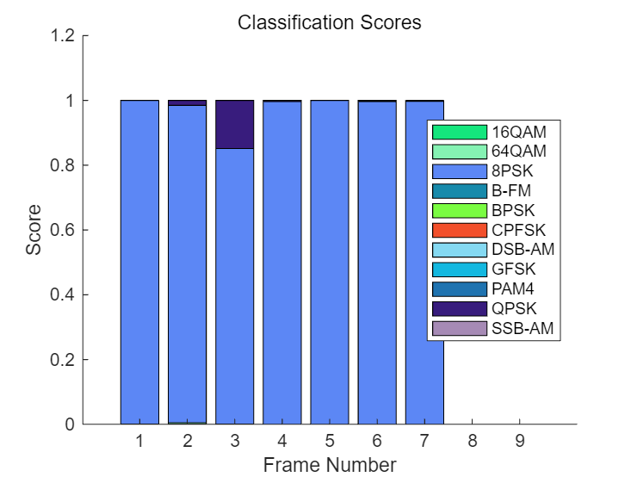

16QAM
helperModClassGetModulator
function y = qam16Modulator(x,sps)
%qam16Modulator 16-QAM modulator with pulse shaping
% Y = qam16Modulator(X,SPS) 16-QAM modulates the input X, and returns the
% root-raised cosine pulse shaped signal Y. X must be a column vector
% of values in the set [0 15]. The root-raised cosine filter has a
% roll-off factor of 0.35 and spans four symbols. The output signal
% Y has unit power.

persistent filterCoeffs
if isempty(filterCoeffs)
filterCoeffs = rcosdesign(0.35, 4, sps);
end
% Modulate and pulse shape
syms = qammod(x,16,'UnitAveragePower',true);
% Pulse shape
y = filter(filterCoeffs, 1, upsample(syms,sps));
end
% Random bits
d = randi([0 15], 1024, 1);
% PAM4 modulation
syms = qammod(d,16,'UnitAveragePower',true);
prediction1 = 7×1 categorical
64QAM
64QAM
64QAM
16QAM
16QAM
64QAM
16QAM
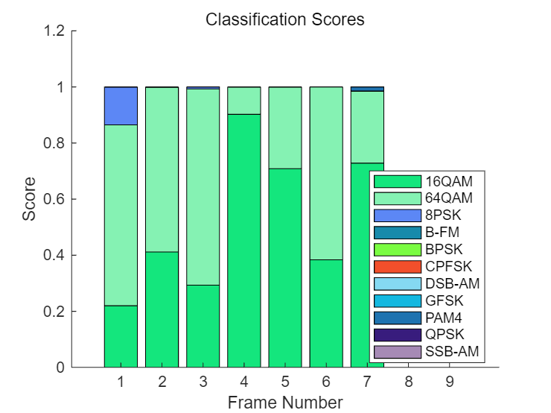

64QAM
helperModClassGetModulator
function y = qam64Modulator(x,sps)
%qam64Modulator 64-QAM modulator with pulse shaping
% Y = qam64Modulator(X,SPS) 64-QAM modulates the input X, and returns the
% root-raised cosine pulse shaped signal Y. X must be a column vector
% of values in the set [0 63]. The root-raised cosine filter has a
% roll-off factor of 0.35 and spans four symbols. The output signal
% Y has unit power.

persistent filterCoeffs
if isempty(filterCoeffs)
filterCoeffs = rcosdesign(0.35, 4, sps);
end
% Modulate
syms = qammod(x,64,'UnitAveragePower',true);
% Pulse shape
y = filter(filterCoeffs, 1, upsample(syms,sps));
end
% Random bits
d = randi([0 63], 1024, 1);
% PAM4 modulation
syms = qammod(d,64,'UnitAveragePower',true);
prediction1 = 7×1 categorical
64QAM
64QAM
64QAM
64QAM
64QAM
64QAM
64QAM
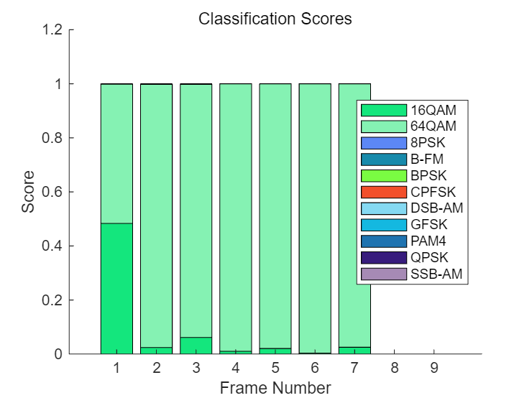

GFSK
helperModClassGetModulator
function y = gfskModulator(x,sps)
%gfskModulator GFSK modulator
% Y = gfskModulator(X,SPS) GFSK modulates the input X and returns the
% signal Y. X must be a column vector of values in the set [0 1]. The
% BT product is 0.35 and the modulation index is 1. The output signal
% Y has unit power.

persistent mod meanM
if isempty(mod)
M = 2;
mod = comm.CPMModulator(...
'ModulationOrder', M, ...
'FrequencyPulse', 'Gaussian', ...
'BandwidthTimeProduct', 0.35, ...
'ModulationIndex', 1, ...
'SamplesPerSymbol', sps);
meanM = mean(0:M-1);
end
% Modulate
y = mod(2*(x-meanM));
end
% the same frames every time the simulation is run
rng(123456)
% Random bits
d = randi([0 1], 1024, 1);
M = 2;
mod = comm.CPMModulator(...
'ModulationOrder', M, ...
'FrequencyPulse', 'Gaussian', ...
'BandwidthTimeProduct', 0.35, ...
'ModulationIndex', 1, ...
'SamplesPerSymbol', 8);
meanM = mean(0:M-1);
tx = mod(2*(d-meanM));
prediction1 = 7×1 categorical
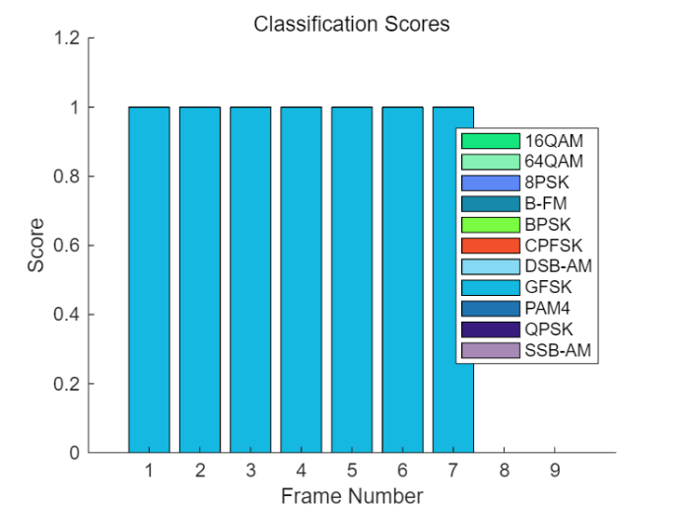
GFSK
GFSK
GFSK
GFSK
GFSK
GFSK
GFSK

CPFSK
helperModClassGetModulator
function y = cpfskModulator(x,sps)
%cpfskModulator CPFSK modulator
% Y = cpfskModulator(X,SPS) CPFSK modulates the input X and returns
% the signal Y. X must be a column vector of values in the set [0 1].
% the modulation index is 0.5. The output signal Y has unit power.

persistent mod meanM
if isempty(mod)
M = 2;
mod = comm.CPFSKModulator(...
'ModulationOrder', M, ...
'ModulationIndex', 0.5, ...
'SamplesPerSymbol', sps);
meanM = mean(0:M-1);
end
% Modulate
y = mod(2*(x-meanM));
end
% the same frames every time the simulation is run
rng(123456)
% Random bits
d = randi([0 1], 1024, 1);
M = 2;
mod = comm.CPFSKModulator(...
'ModulationOrder', M, ...
'ModulationIndex', 0.5, ...
'SamplesPerSymbol', 8);
meanM = mean(0:M-1);
tx = mod(2*(d-meanM));
prediction1 = 7×1 categorical
CPFSK
CPFSK
CPFSK
CPFSK
CPFSK
CPFSK
CPFSK
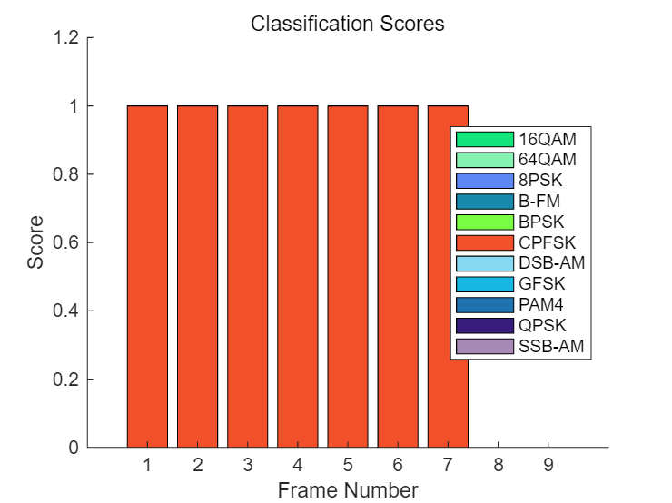
PAM4
helperModClassGetModulator
function y = pam4Modulator(x,sps)
%pam4Modulator PAM4 modulator with pulse shaping
% Y = pam4Modulator(X,SPS) PAM4 modulates the input X, and returns the
% root-raised cosine pulse shaped signal Y. X must be a column vector
% of values in the set [0 3]. The root-raised cosine filter has a
% roll-off factor of 0.35 and spans four symbols. The output signal
% Y has unit power.

persistent filterCoeffs amp
if isempty(filterCoeffs)
filterCoeffs = rcosdesign(0.35, 4, sps);
amp = 1 / sqrt(mean(abs(pammod(0:3, 4)).^2));
end
% Modulate
syms = amp * pammod(x,4);
% Pulse shape
y = filter(filterCoeffs, 1, upsample(syms,sps));
end
% Random bits
d = randi([0 3], 1024, 1);
% PAM4 modulation
syms = pammod(d,4);
prediction1 = 7×1 categorical
PAM4
PAM4
PAM4
PAM4
PAM4
PAM4
PAM4
